
Tarporley Pre-School
Rear of St.Helens Church,
High Street,
Tarporley, Cheshire CW6 0AG
Telephone: 01829 730233
Reg No: 1175784
Email: Tarporleypre-school2@btconnect.com
APPLICATION FORM
CHILDS DETAILS

Name of Child:----------------------------------------------- Date of Birth:---------------------------------------------------
Parent/Guardian Contact Details

Parent/Guardian (1):----------------------------------------- Parent/Guardian(2):----------------------------------------------

Relationship:-------------------------------------------------- Relationship:-----------------------------------------------------
Address:------------------------------------------------------------------------------------------------------------------------------

Postcode:…………………………………………………… Phone No:----------------------------------------------------------

Email address: ------------------------------------------------------------------------------------------------------------------------

Attendance:38 wks (term time) 50 Wks (Closed for 2 weeks at Christmas)Please circle.
Preferred StartDate:------------------------------------

NB: We are open Monday – Friday, morning session 8.50am – 11.50am and afternoon session 11.50 -2.50pm. Our Policy is that your child attends a minimum of two separate sessions per week.

^{SESSIONS AVAILABLE} | ^{MONDAY} | ^{TUESDAY} | ^{WEDNESDAY} | ^{THURSDAY} | ^{FRIDAY}
^{Breakfast Club-7.50am}
EarlyDropOff-8.30 am (Not part of the funded hours)
^{Morning Session 8.50-11.50am}
Afternoon Session 11.50am-2.50pm
^{Late Collection 2.50pm-3.50pm}
^{After School3.50pm – 5.50pm}
EYFS FUNDING: If your child is entitled to the EYFS Funding could you please advise the Pre-school if you attend any other settings and how you wish to claim for your sessions within this setting.
Please note if your requested start date is mid-term you will not be able to apply/transfer funding over to us, this may result in you waiting until the new term starts.
We do not accept 9 months to 2 year funding! All funding does not start until the term after your child’s birthday.

If you are moving into the area please provide previous setting details: --------------------------------------------------------------

Would you like a Home Visit to take place before your start date?. YES/NO

Sign:----------------------------------------------------------- Date:--------------------------------------------------------------

ADMINISTRATION ON RETURN OF APPLICATION FORM:

1 | Confirm Application - Email
2 | Re-confirm half term before -Email
3 | Send Registration form, ICEform Parent Contract/EYFS/About our childcare/information EYLOG/ Parents Privacy Notice– viaEmail
4 | Funding form/ Privacy Notice/Funding Guidance/Additional charge – if Applicable
5 | Medical Action Plan – if Applicable
6 | Request a Family Photo, Proof of immunisations, and the Birth Certificate
7 | Return of Registration form, ICE form/ Parent Contract/Funding Form/Action Plan - Highlight to confirm receipt.
8 | Registration form checked for Allergies or concerns and noted
8 | Confirm Start Date& Keyperson send out First Day Letter and Keyperson information
9 | Arrange a Taster Session, baseline and Re-confirm a Start date.
10 | Reconfirm the start date – along with the Bill - Email

Baseline Date and Time………………………………………………………….

Taster session Date and Time:………………………………………………..

Start Date…………………………………………………………………………………..

ALL PAPERWORK/REQUESTS YOU HAVE BEEN ASKED TO COMPLETE MUST BE RETURNED AT LEAST 2 WEEKS BEFORE YOUR CHILD’S START DATE, FAILURE TO DO SO WILL RESULT IN A DELAY IN YOUR CHILD’S START DATE.

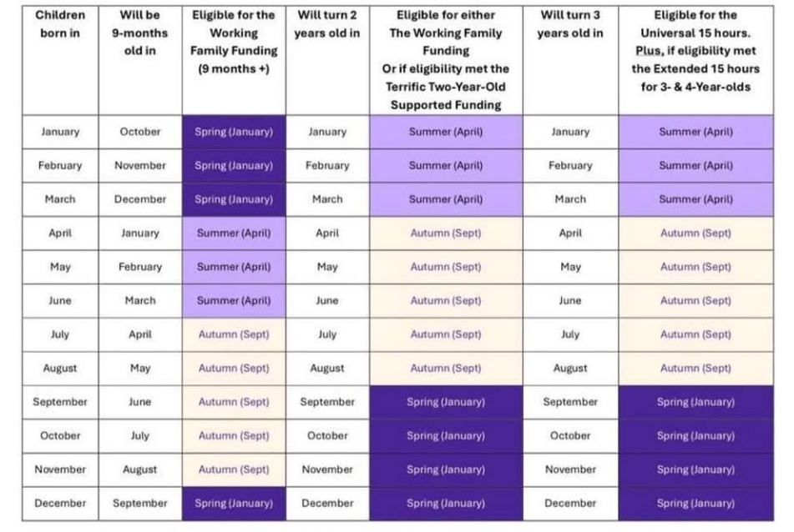
Funding Eligibility Table

We
do
not
accept
9 month
to
2year
funding
[Grab your reader’s attention with a great quote from the document or use this space to emphasize a key point. To place this text box anywhere on the page, just drag it.]

